**Developing Drawing App in Microsoft PowerApps**

**Introduction**In this article, we are going to see how to Develop Drawing App in Microsoft PowerApps.

In PowerApps, we can Add the Radio Button Control.

**Pen Input Control:**Pen Input Control is used to **Draw, Erase and Highlight** the areas in the image. Its an input interface for getting the User Handwriting and convert it into images.

Here we are developing the drawing App using this **Pen Input Control and Save** those drawing images to the Image Gallery as well as we can also **delete them** from the Image Gallery.

Follow the below steps to develop the Drawing App in PowerApps:

**Step 1: Log into the PowerApps**

After downloading the PowerApps from the window store, here we need Microsoft related organization’s Office 365 ID or (MSDN, Microsoft, Skype, Office 365 etc.,), to login with it.

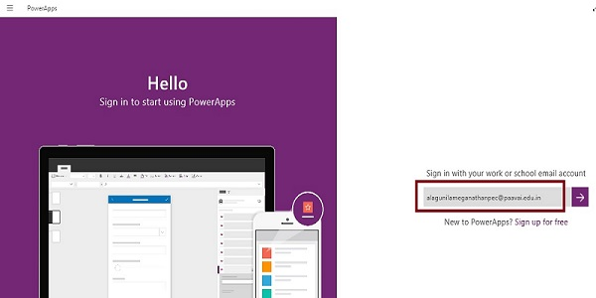

**Step 2: Create a New App in PowerApp**

After Login, we can see the Dashboard. There we click on the **New** button.

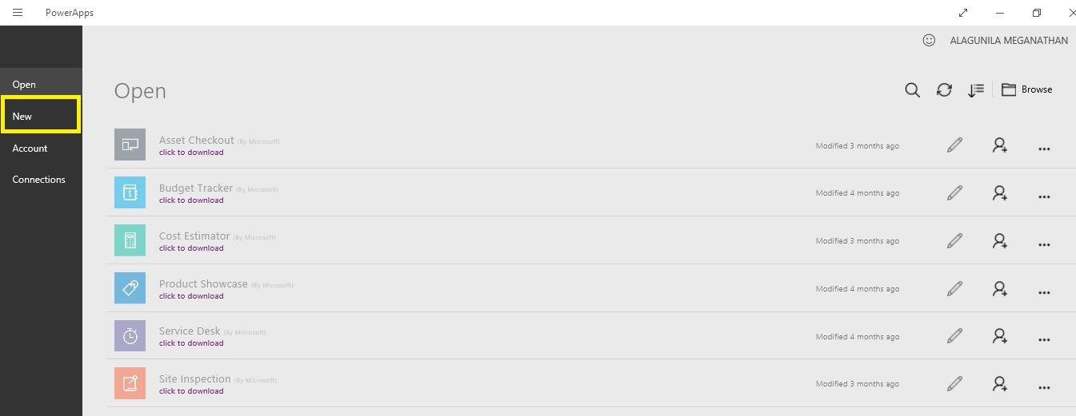

**Step 3: Choose the Blank App**

.

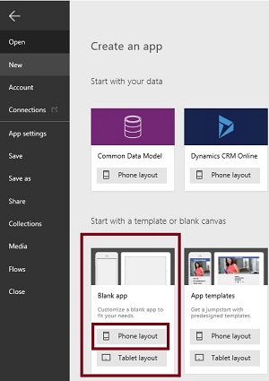

**Step 4: Designing the App**

Now, let's start to designing the App. In left side we can see the **Individual Screens** for adding our data. In Right side we see the List of **Layouts**. In the Top we see the formula bar. There you seen the **Properties** of the screen what you select. In the Right Side we see the Add Data Source to add the External data Source.

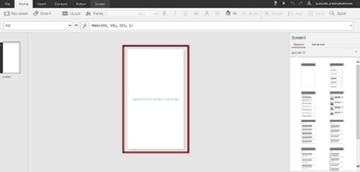

**Step 5: Drag and Drop the Pen Input Control**

1. **Go to the Insert menu then Controls and Drag the Pen Input tool.**

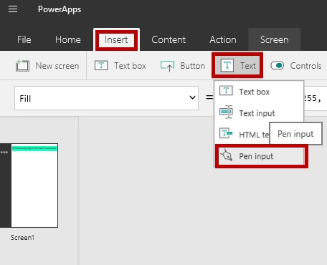

1. **Drop the Pen Input tool on the Screen.**

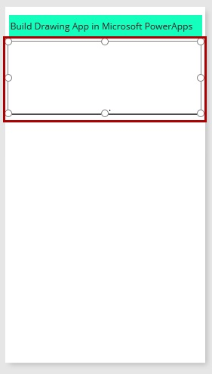

1. **Rename the MyPen**

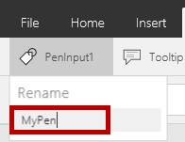

**Step 7: Drag and Drop the Button Control Tool**

The Button Control is used for saving the drawing to the Image Gallery.

1. **Go to the Insert Menu and Drag the Button Control.**

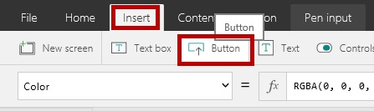

1. **Drag the Button control to the screen.**

Place it in the Screen and change the name to Save

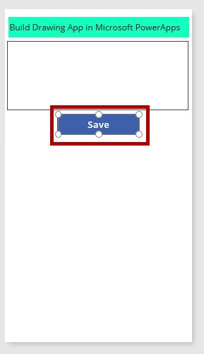

1. **Add the Coding**

Now **Select the Button Control** and add the coding to the **OnSelect Event**.

**Coding:**

**Collect(ImageSave, {Sketch:MyPen.Image})**

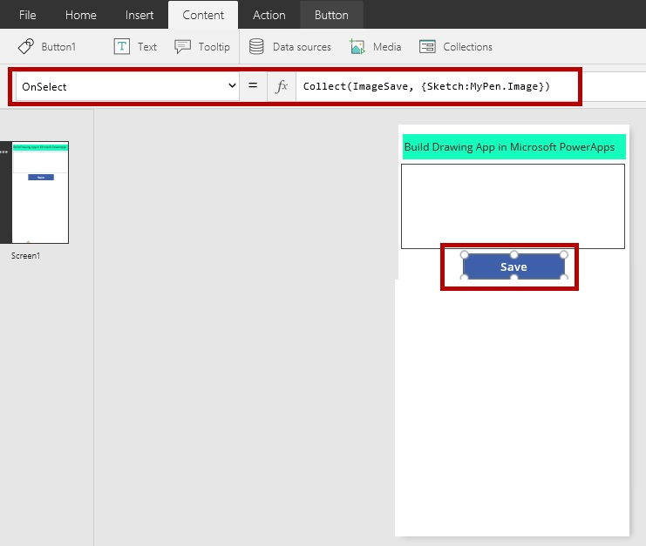

**Step 7: Drag and Drop the ImageGallery Control Tool**

The ImageGallery Control is used for saving the drawing.

1. **Go to the Insert Menu and Drag the Vertical Image Only Control.**

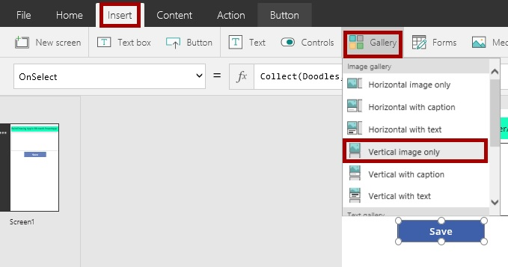

1. **Drag the ImageGallery control to the screen.**

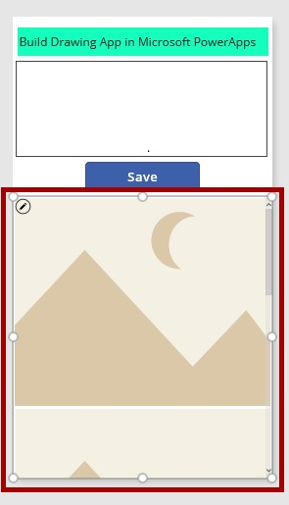

1. **Add the Coding**

First, Select the Image and add the **ImageSave** to the **Items** Event

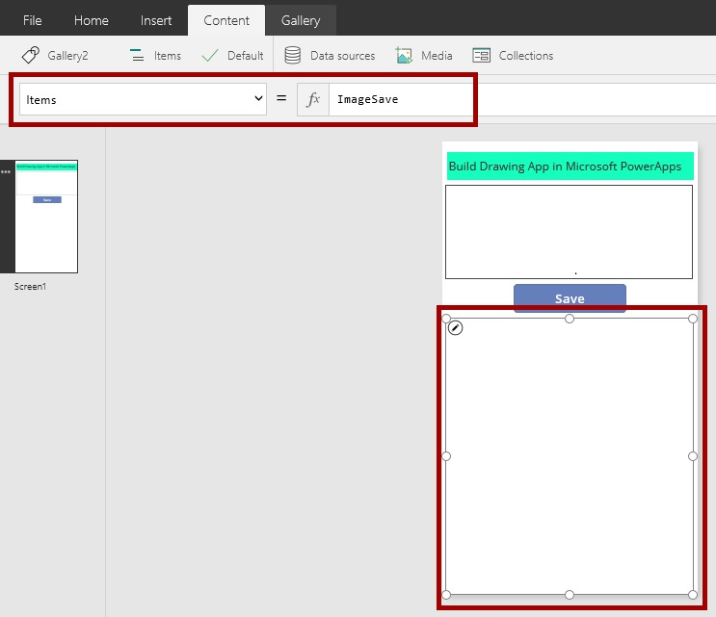

**Second,** select the individual image and add the following coding to the **OnSelect** Event

**Coding:**

**Remove(ImageSave, ThisItem)**

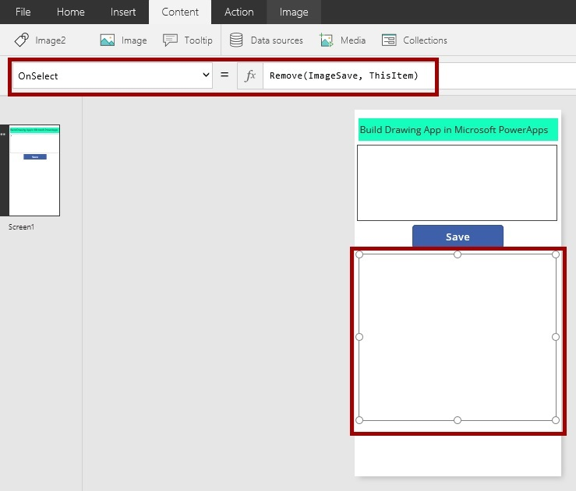

**Step 8: Run the App**



**Output 1: Main Screen**

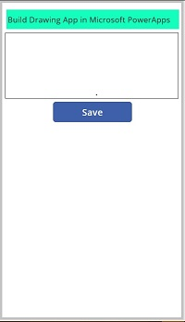

**Output 2: Sketch it and tap the Save.**

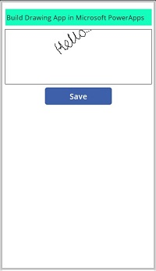

**Output 3: Saved into the ImageGallery**

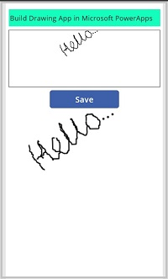

**Output 4: Again sketch and save**

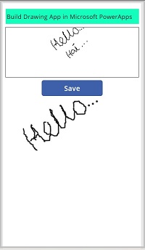

**Output 5: Saved**

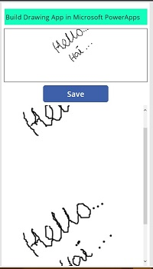

**Output 6: Just Select and Remove it**

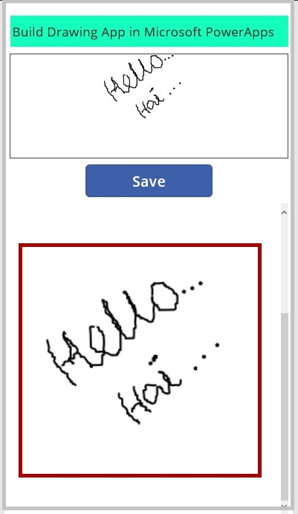

**Output 7: Removed.**

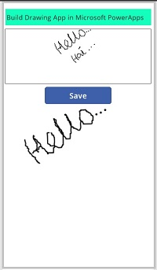

**Conclusion:**

I hope you understood the How to Develop the Drawing App in Microsoft PowerApps and how to run it.